SIMATS ENGINEERING (SAVEETHA SCHOOL OF ENGINEERING)
Department of Computer Science and Engineering
ASSESSMENT TOOL 2 –DAST SIMULATION

Course Code: | CSA5802 | Course Title: | DEVSECOPS ENGINEERING AND APPLICATION SECURITY
CO Assessed: | CO3 – Precision (BL1, BL2, BL3) | Assessment: | Assessment Tool 2
Weightage: | 30% of CIA | Total Marks: | 100
CO3 Statement: | Simulate Dynamic Application Security Testing (DAST) and Software Composition Analysis (SCA).
Student Name: | Y.Devi Priya | Reg. No.: | 192465042
Section / Batch: | Cse cyber security | Date: | 12-08-2026
Instructions to Students

- Ensure all diagrams and workflow illustrations are original, clear, and professionally formatted.
- Include all editable source files (such as .yml, .py, requirements.txt, .pre-commit-config.yaml, and any diagram source files if applicable).
- Submit both the GitHub repository link and the final PDF report through Google Classroom before the specified deadline.
- Verify that the GitHub repository is accessible and contains all required project files, screenshots, and documentation.

Question Type | Focus Area | Questions | Marks
DAST SIMULATION | Application based | Q1 | Q1 –100
GRAND TOTAL: |  | 100 Marks

Code of Conduct
I (Name / Reg No) certify that this submission is my original work and that I have adhered to the guidelines specified for this assessment. I understand that any violation of academic integrity rules will result in disciplinary action.
Signature of the Student:

RUBRICS FOR CALCULATION

Criteria | Wt. | Level 4 – Exemplary | Level 3 – Proficient | Level 2 – Developing | Level 1 – Beginning
Understanding of Problem Context | 20% | Clearly understands the problem and accurately identifies all requirements | Good understanding with minor gaps | Basic understanding; some requirements unclear | Poor understanding or misinterpretation of the problem
Application of Concepts | 30% | Accurately applies appropriate concepts to solve complex problems | Applies relevant concepts correctly with minor errors | Applies basic concepts with limited accuracy | Fails to apply appropriate concepts
Problem-Solving Approach | 20% | Logical, well-structured, and efficient approach | Mostly logical approach with minor gaps | Basic approach with some inconsistencies | Illogical or unclear approach
Accuracy of Solution | 20% | Completely correct solution with proper justification | Mostly correct with minor errors | Partially correct solution | Incorrect or incomplete solution
Clarity | 10% | Clear, well-organized, and properly explained solution | Understandable with minor clarity issues | Limited clarity and explanation | Poorly presented and difficult to understand

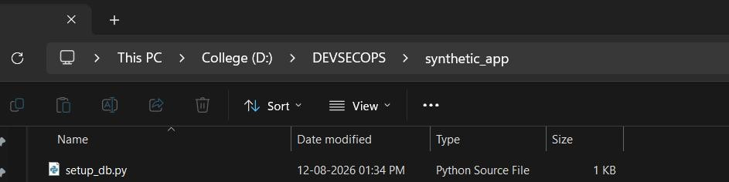
Step 1 — Add a real database so the app actually works

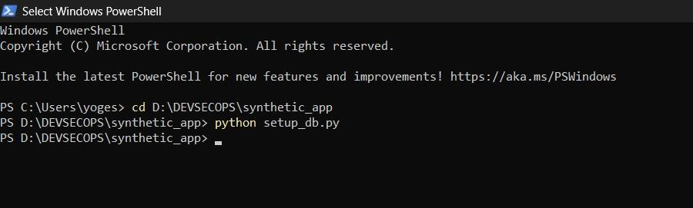

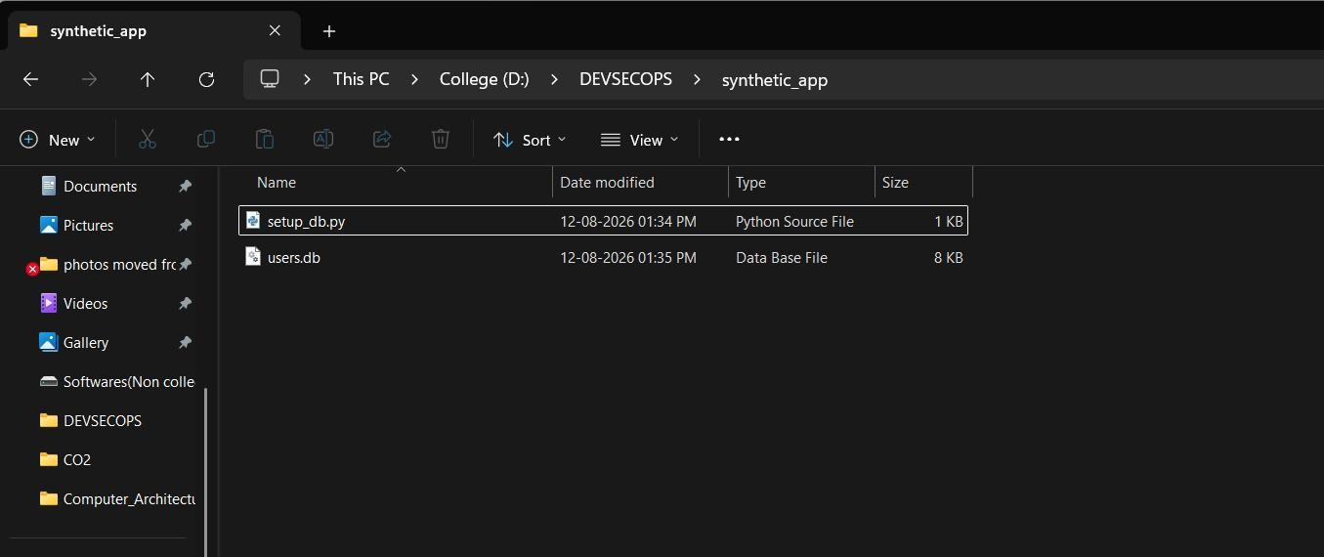
Step 2 — Install Flask and run the app

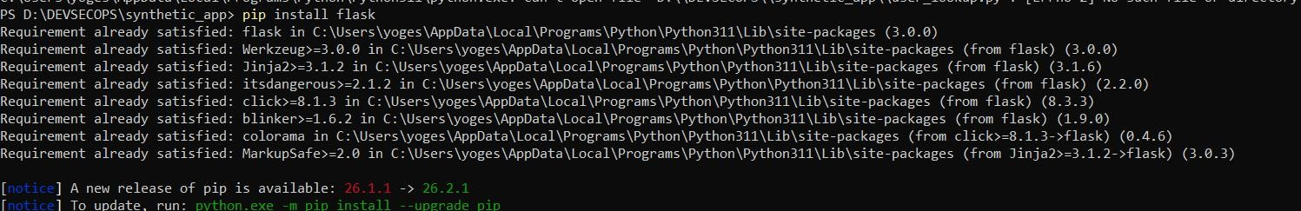

Step 3 — Point ZAP at your running app

- In ZAP, go to the Quick Start tab
- Enter target URL: http://127.0.0.1:5000/user?username=test
- Click Attack (Automated Scan)

Step 4 — Manually confirm the SQL injection (proof-of-concept)
While the app is running, open a browser and test:

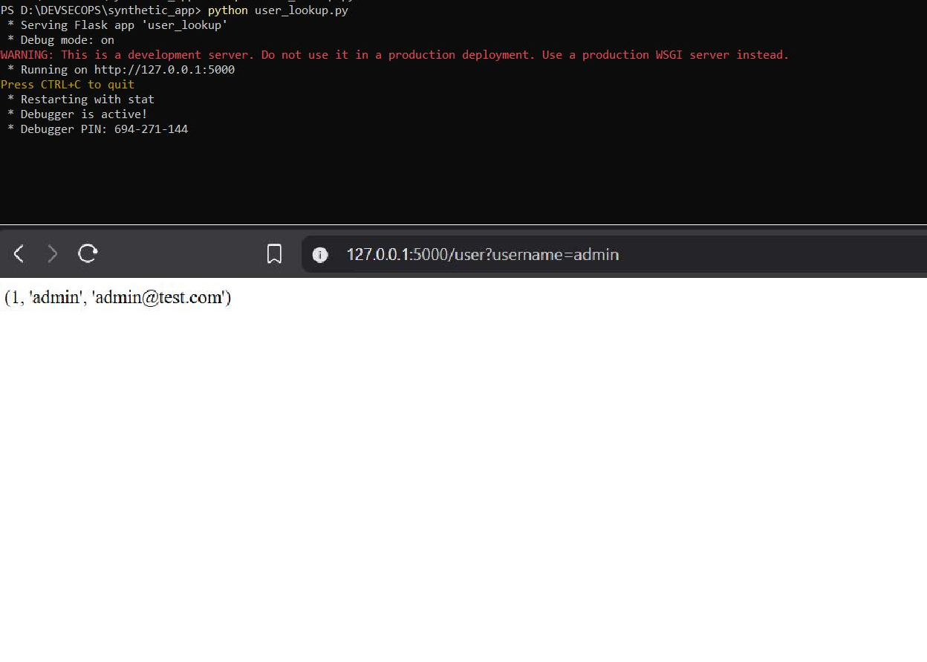
http://127.0.0.1:5000/user?username=' OR '1'='1

